French & Indian War Information Sheet
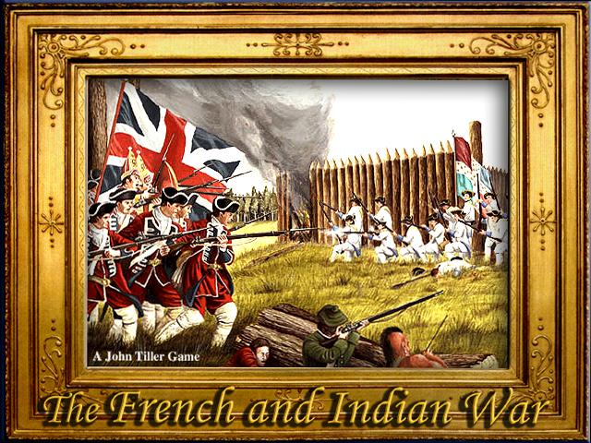

In the 1750’s, Britain and France had colonies in North America. Both the British and the French were competing for control of a valuable area called the Ohio River Valley. This area was a great location for fur trading with Native Americans who lived there. In an effort to protect their trade with Native Americans, the French built forts in the Ohio Valley on land claimed by the colony of Virginia. When the French refused to give up their forts in 1754, George Washington led an army against the French. He was defeated, and soon after Britain declared war on France. Most Native Americans in the region were allies of the French because the French traded with them, but did not settle on their land like the British.
In 1754, a congress of the British colonies met in Albany, New York to discuss how to overcome the French. Benjamin Franklin thought it best for the colonies to work together to defeat France. His proposal was called the Albany Plan of Union where each colony would still have its own government but would be united under a central government to decide on important issues together. The colonial governments rejected it. They did not want to lose their power to a central government.
In 1759, Britain sent more soldiers to North America and captured Quebec, the capitol of New France. This signaled the defeat of the French and in 1763, Britain and France ended the war and signed the Treaty of Paris of 1763. France was forced to give Britain control of Canada and most of the land east of the Mississippi River which made England the dominant country in North America.
In addition to becoming the dominant country in North America, England also acquired heavy debts from the French & Indian War. Because of these debts, the British Parliament passed several policies that taxed the American Colonies in an effort to pay those debts. These policies angered many colonists and created much tension between England and the Colonies

French & Indian War Debrief Activity
- What two major countries were involved in the French & Indian War and why were they fighting?
- George Washington plays different roles during the American Revolution. What role does he play in the French & Indian War?
- Write a one-sentence explanation of Benjamin Franklin’s drawing?
- What was the colonial response to the Albany Plan of the Union?
- Highlight 2 major outcomes of the French & Indian War.

